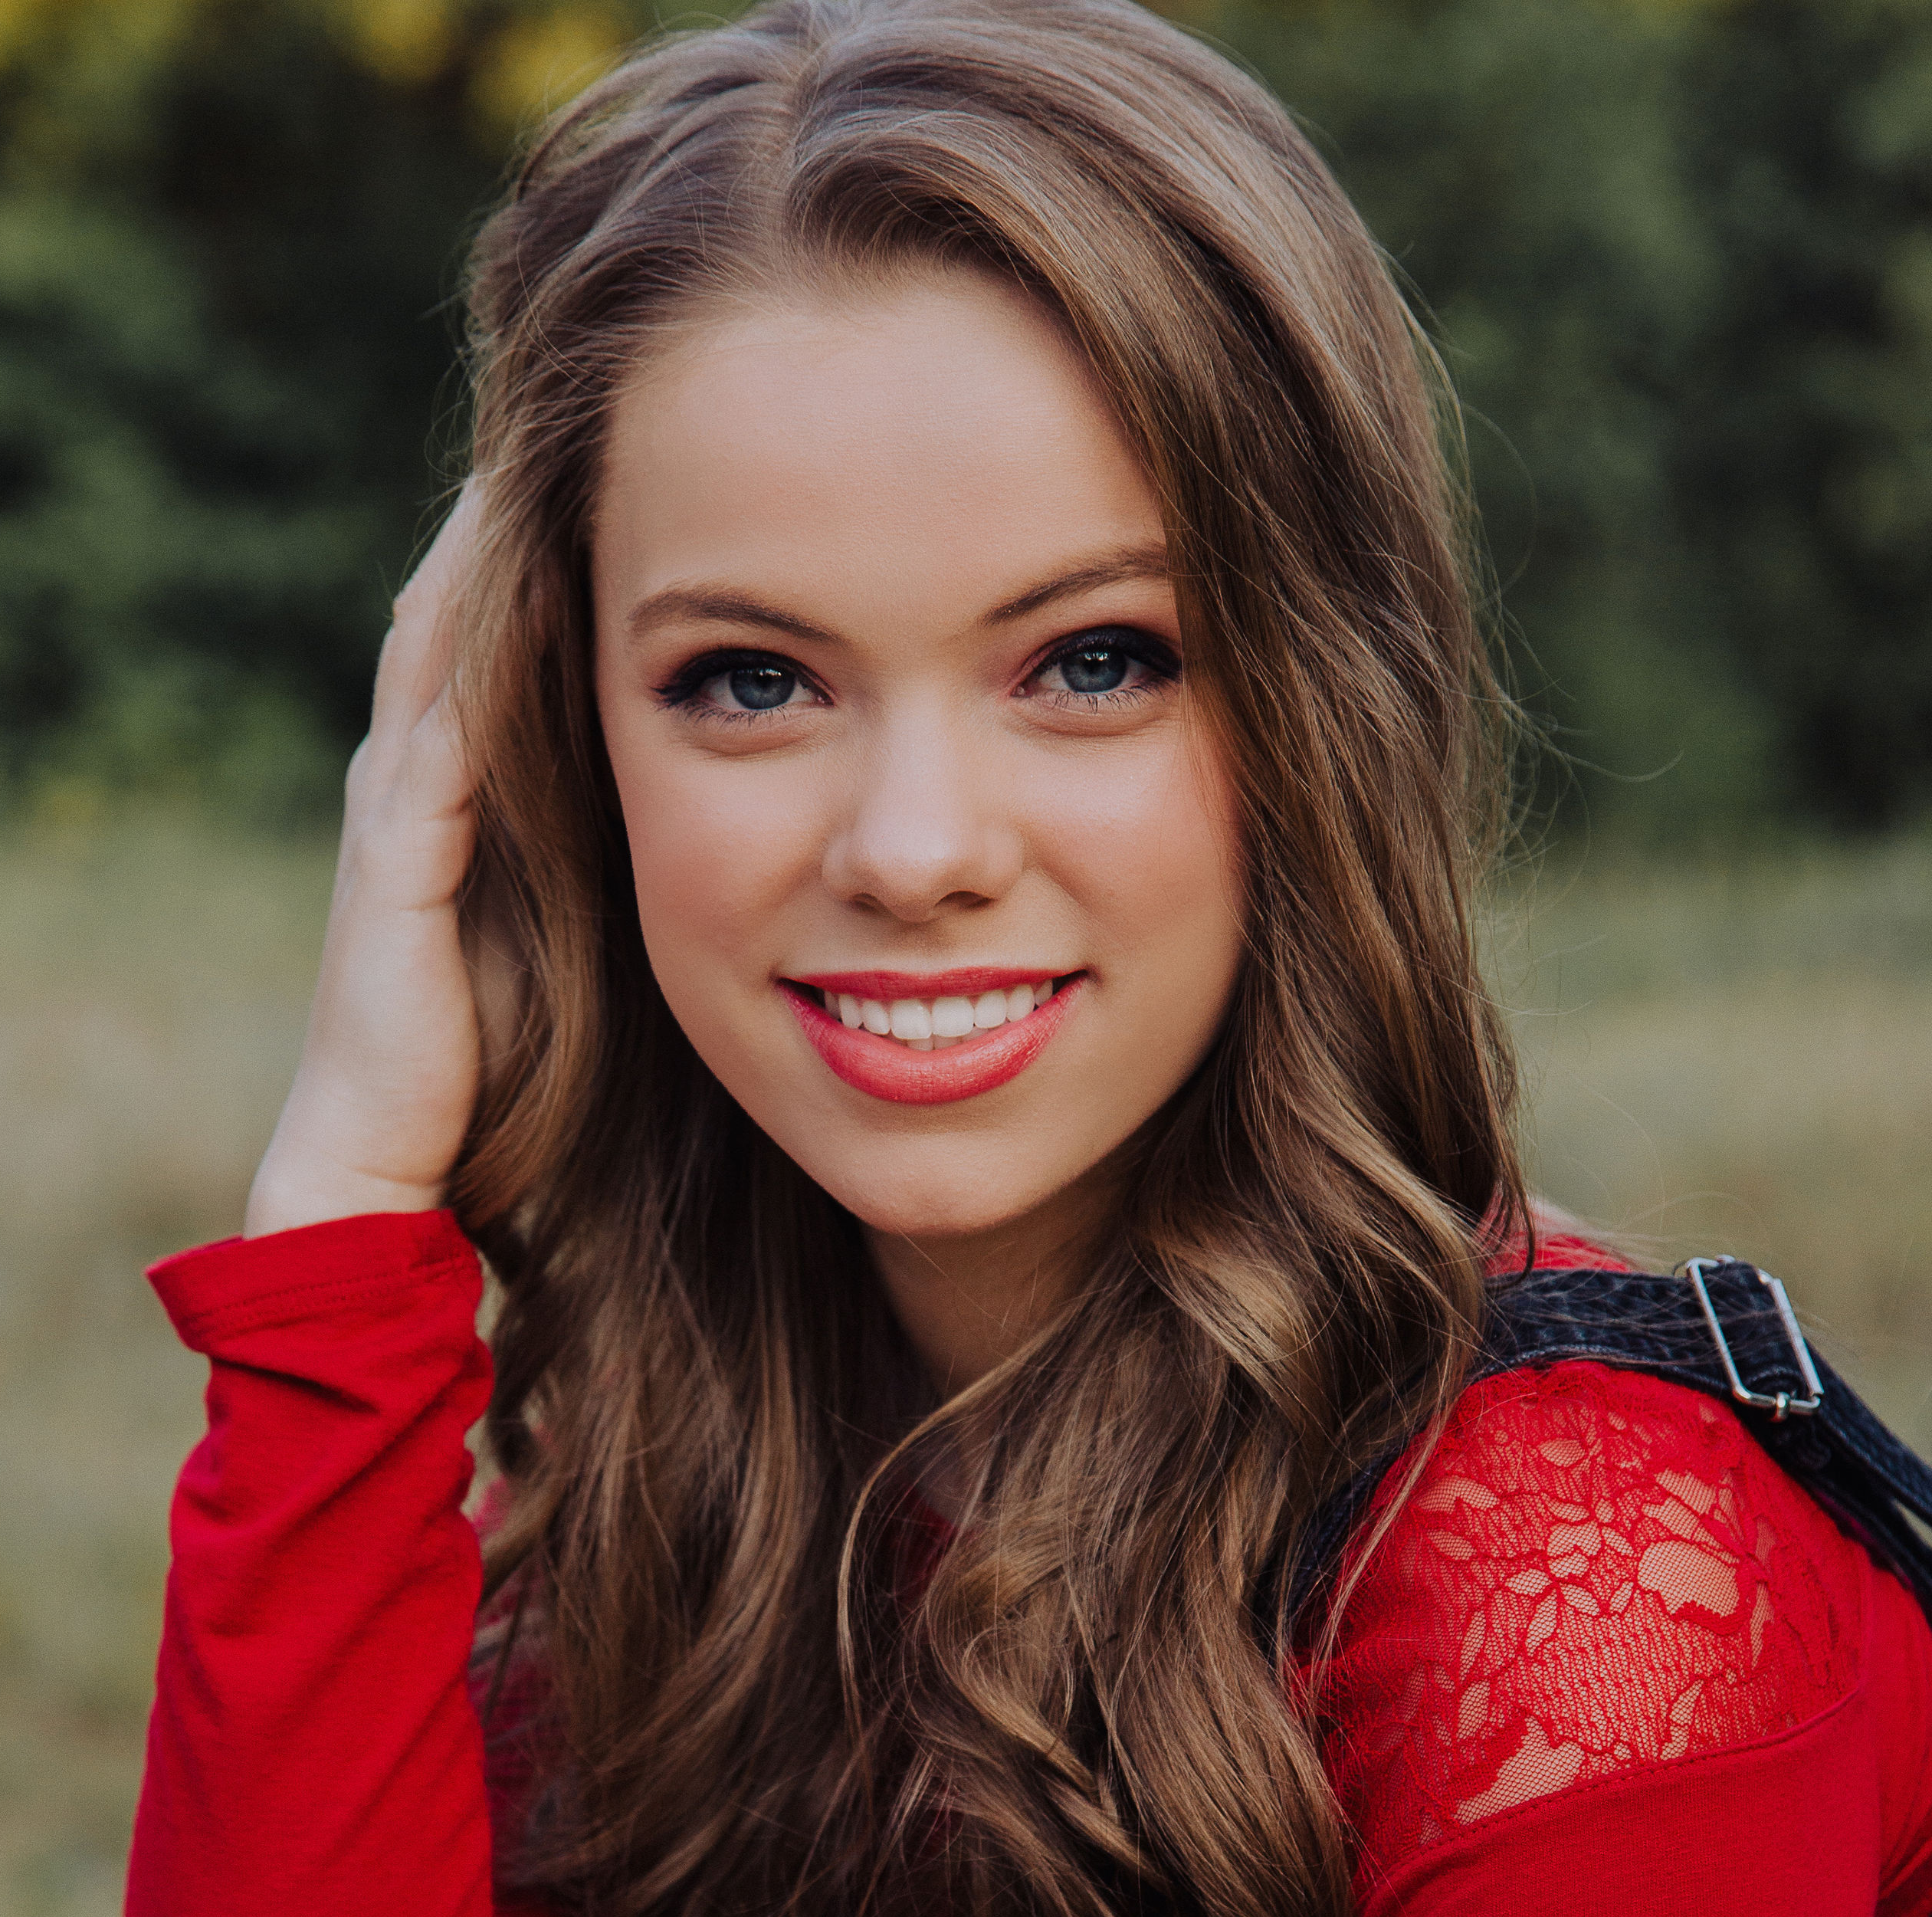

Performing Experience:
Musical | Role | Theater | Director
Something Rotten | Portia | Genesis Children’s Theatre | Megan Demsky
The Mystery of Edwin Drood | Rosa Bud | Genesis Children’s Theatre | Megan Demsky
How To Succeed In Business Without Really Trying | Featured Dancer/ Ensemble | Genesis Children’s Theatre | Megan Demsky
Little Women | Amy March | Legacy Christian Academy | Amanda Wenk
Mary Poppins | Mrs. Smythe/ Chimney Sweep/ Statue Dancer | Shine Performing Arts | Claire McNeil
Shrek | Dragon | Shine Performing Arts | Claire McNeil
Seussical | Sour Kangaroo | Shine Performing Arts | Deedra Scherm
Fiddler on the Roof | Chava | Shine Performing Arts | Claire McNeil
High School Musical 2 | Sharpay Evans | Shine Performing Arts | Claire McNeil
Wizard of Oz | Dorothy Gale | Shine Performing Arts | Claire McNeil
Peter Pan | Indian Dancer | Legacy Christian Academy | Amanda Wenk
Seussical | Bird Girl | Legacy Christian Academy | Karla Kelley
Annie | Kate | Legacy Christian Academy | Karla Kelley
Straight Play | Role | Theater | Director
Fearful Symmetry | Mary (French) | Legacy Christian Academy | Amanda Wenk
Dark Road | Greta | Legacy Christian Academy | Amanda Wenk
Man Of the House | Mama | Legacy Christian Academy | Amanda Wenk
Snow White | Rosalys | Legacy Christian Academy | Amanda Wenk
Alice in Wonderland | Alice | Legacy Christian Academy | Amanda Wenk
Eurydice | Eurydice | Genesis Children’s Theatre | Meg Sullivan
Shakespeare | Role | Theater | Director
Twelfth Night | Olivia | Genesis Children’s Theatre | Meg Sullivan

Dance Experience:
Golden Stars Dance Team for 2 years Legacy Christian Academy, Sheena Laramore
TAPPS Competition with the Golden Stars Legacy Christian Academy, Sheena Laramore

Choir Experience (6th – 12th Grade):
All Region Choir four consecutive years (2016-2020)
All State Choir two years (2019-2020)

Directing/Leading Experience:
Music Team for Fine Arts Day Camp, 5 consecutive years Marcelle Hamilton (June 2015-2019)
Elementary Worship Team, 6 years Marcelle Hamilton (2015-2020)
Assistant Choir Director, one year Chris Keyes (2019-2020)

Training:
Acting lessons, one year Mary Margaret Gates
Voice lessons, 8 years Katelyn Parks
Voice lessons, 2 years Tina Walsh
Beginner Tap, one year Mary Margaret Gates
Beginner Ballet, one year Lauren Builderback

Special Skills:
Plays ukulele, British (London Dialect), French dialect, Harry Potter enthusiast, tree climber, passionate about stars, loves Greek Mythology (Percy Jackson series), has driver’s license, cartwheels, somersaults, model experience

